Project 2
Data Discovery
The first thing that I did was get a feel for the data that I would be working with. Upon simply plotting the digits, I can see that this is an MNIST dataset that has some noise overlaid into it. A sample plot of some of the digits may be found below.
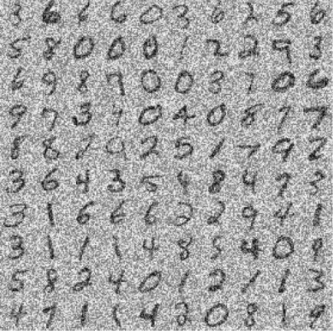
Figure 1: Noisy MNIST Data Sample
Since the project does not call for the use of a pipeline, the noise shall remain. Sometimes the introduction of noise into such a dataset may in fact help the models that I develop generalize better.
Model 1: SVM
My original plan for this model would be to use sklearn’s SVC class, however it takes a rather long time to fit and make predictions on my machine. According to the scikit help page on SVC, they recommend using the SGDClassifier, which I decided would be a good tradeoff for a speedier implementation.
My first attempt at using the SVM gave me a nice-looking model with a confusion matrix that matched the one below. With a reported accuracy score of about 73.1% on the test set, 70.3% on the validation set and 75.8% on the dataset using cross-validated predictions.
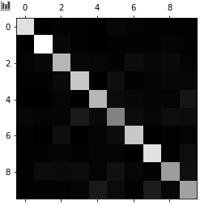
Figure 2: Confusion matrix from un-optimized SVM model.
That’s ok, but I bet it would be better if I used grid search to optimize the hyperparameters. While using Grid Search, I was sure to set the scoring metric to ‘accuracy’ since the project doc said this would be the metric for grading. For the SVM I chose some hyperparameters that I wanted GridSearchCV to look for. The table below represents the hyperparameters that I let it decide and how it decreed. The corresponding call that I make to GridSearch for the three models is found in Appendix A.
Table 1: Showcasing GridSearch’s decision for which parameters to use on the model.
Parameter | Options | Decision
loss | hinge, huber | hinge (default)
penalty | l2, l1, elasticnet | l2 (default)
alpha | 1, 0.01, 0.0001 | 1
shuffle | True, False | True (default)
learning_rate | adaptive, optimal, invscaling | adaptive
eta0 | 0.25, 0.5, 0.75, 1.0 | 0.75
power_t | 0.5, 0.25, 0.10 | 0.25
early_stopping | True, False | False (default)
After optimizing with GridSearch, I was able to raise the test accuracy to 81.2%, the validation accuracy to 78.1% and the cross-validation accuracy to 78%. The corresponding confusion matrix may be found below. The final function call for creating the SVM may be found in Appendix B.
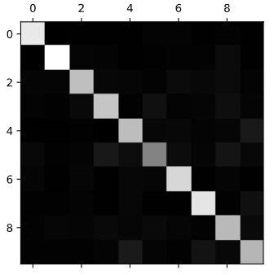
Figure 3: Confusion matrix of GridSearch optimized SVM model.
I believe that the model works better with these optimizations in the following ways.
Model 2: Random Forest
I figured that since this is an ensemble learner that we are building that a random forest which works with a bunch of trees would be a great addition. The details for how I optimized this tree is shown below. Note that I have excluded measures of scoring as I have aggregated all of the numbers into Table 4. The values that I tested with GridSearch and the decided upon values for optimization are shown below, as well as the confusion matrix for the optimized random forest.
Table 2: Showcasing GridSearch’s decision for which parameters to use on the model.
Parameter | Options | Decision
n_estimators | 1000, 100, 10 | 1000
criterion | gini, entropy | gini
oob_score  (Out-of-bag) | True, False | True
Figure 4: Confusion matrix of GridSearch optimized random forest model (NOT RIGHT).
Model 3: Logistic Regressor
Finally, I decided to use a logistic regressor due to it’s quicker predictions and to reduce the risk of overfitting by the random forest model. I figure this model is a good sweet-spot between the SVM and the random forest. Same as before, I present the optimized parameters and the corresponding optimized model’s confusion matrix.

Table 3: Showcasing GridSearch’s decision for which parameters to use on the model.
Parameter | Options | Decision
penalty | l2, l1 | l1
solver | newton-cg, lbfgs, liblinear, saga | liblinear
C | 1, 0.01, 0.0001 | 0.0001
fit_intercept | True, False | False
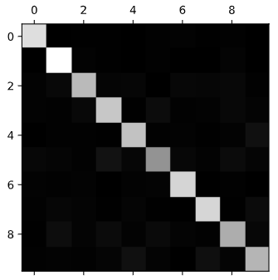
Figure 5: Confusion matrix of GridSearch optimized logistic regression mode.l

Model 4: Ensemble
The ensemble is built using the three models. The linear SVM may work well for digit comparisons that are relatively far apart from each other in their similarities such as digits 7 and 8. The random forest learned the patterns of the test set extremely well and showed to expand nicely to validation attempts. The logistic regressor introduces some more nonlinearity to the decision boundaries allowing for more complex decision-making than the SVM but without the potential over-fitting of the random forest. The following table showcases the relative improvement of the individual models compared to their non-optimized selves as wells as the final accuracies for the ensemble model.
Table 4: Aggregate of all accuracy values.
Model | Test Score | Validation Score | Cross-Validation Score
SVM | 73.1% | 70.3% | 75.8%
SVM Optimized | 81.2% (+8.1%) | 78.1% (+7.8%) | 78% (+2.2%)
Random Forest | 100% | 85.1% | 84.8%
Random Forest Optimized
Logistic Regression | 86.6% | 82.8% | 82.6%
Logistic Regression Optimized | 84.7% (-1.9%) | 83.7% (+0.9%) | 83.3% (+0.7%)
Ensemble | 90.3% | 85.6% | 84.6%

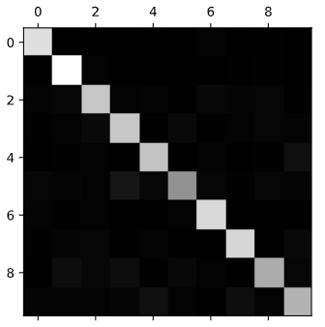
Figure 6: Confusion matrix of the final ensemble model.

Appendix A: GridSearchCV Call
grid_search = GridSearchCV(***_model, param_grid, cv=5,
scoring='accuracy',
return_train_score=True,
n_jobs=-1)

Appendix B: SVM Instantiation
svm_model = SGDClassifier(loss='hinge', penalty='l2',
alpha=1, shuffle=True, learning_rate='adaptive',
eta0=0.75, power_t=0.25, early_stopping=False)

Appendix C: Random Forest Instantiation
rf_model = RandomForestClassifier(n_estimators=1000, criterion='gini',
oob_score=True)

Appendix D: Logistic Regression Instantiation
logr_model = LogisticRegression(C=0.0001, fit_intercept=False, multi_class='ovr',
penalty='l1', solver='liblinear')

Appendix E: Ensemble Instantiation
ensemble_model = VotingClassifier(
estimators=[('svm', svm_model), ('rf', rf_model), ('logr', logr_model)],
voting='hard')

